INGLESIDE INDEPENDENT SCHOOL DISTRICT

RESOLUTION # 323-10-22 CREATING THE ENBRIDGE REINVESTMENT ZONE NO. 001
WHEREAS, Section 312.0025 of the Texas Tax Code permits a school district to designate a reinvestment zone if that designation is reasonably likely to contribute to the expansion of primary employment in the reinvestment zone, or attract major investment in the reinvestment zone that would be a benefit to property in the reinvestment zone and to the school district and contribute to the economic development of the region of this state in which the school district is located; and,

WHEREAS, the Ingleside Independent School District (the “District”) desires to encourage the development of primary employment and to attract major investment in the District and contribute to the economic development of the region in which the school district is located; and,

WHEREAS, a public hearing is required by Chapter 312 of the Texas Tax Code prior to approval of a reinvestment zone; and,

WHEREAS, the District published notice of a public hearing regarding the possible designation of the area described in the attached Exhibit A as a reinvestment zone for the purposes of Chapter 313 of the Texas Tax Code; and,

WHEREAS, the District wishes to create a reinvestment zone within the boundaries of the school district in Ingleside Texas as shown on the map attached as Exhibit B; and,

WHEREAS, the District has given written notice of the proposed action and the Public Hearing to all political subdivisions and taxing authorities having jurisdiction over the property proposed to be designated as the reinvestment zone, described in the attached Exhibits A & B; and,

WHEREAS, all interested members of the public were given an opportunity to make comments at the public hearing.

NOW, THEREFORE, BE IT RESOLVED BY THE BOARD OF TRUSTEES OF THE INGLESIDE INDEPENDENT SCHOOL DISTRICT:

SECTION 1. That the facts and recitations contained in the preamble of this Resolution are hereby found and declared to be true and correct.

SECTION 2. That the Board of Trustees of the Ingleside Independent School District, after conducting such hearing and having heard such evidence and testimony, has made the following findings and determinations based on the evidence and testimony presented to it:

- That the public hearing on the adoption of THE ENBRIDGE REINVESTMENT ZONE NO. 001 has been called, held and conducted, and that notices of such hearing have been published and mailed to the respective presiding officers of the governing bodies of all taxing units overlapping the territory inside the proposed reinvestment zone; and,

- That the boundaries of THE ENBRIDGE REINVESTMENT ZONE NO. 001 be and, by the adoption of this Resolution, are declared and certified to be the area as described in the description attached hereto as “Exhibit A”; and,

- That the map attached hereto as “Exhibit B” is declared to be and, by the adoption of this Resolution, is certified to accurately depict and show the boundaries of THE ENBRIDGE REINVESTMENT ZONE NO. 001 which is described in Exhibit A; and further certifies that the property described in Exhibit A is inside the boundaries shown on Exhibit B; and,

- That creation of THE ENBRIDGE REINVESTMENT ZONE NO. 001 with boundaries as described in Exhibit A and Exhibit B will result in benefits to the Ingleside Independent School District and to land included in the zone, and that the improvements sought are feasible and practical; and,

- That the THE ENBRIDGE REINVESTMENT ZONE NO. 001 described in Exhibit A and Exhibit B meets the criteria set forth in Texas Tax Code §312.0025 for the creation of a reinvestment zone as set forth in the Property Redevelopment and Tax Abatement Act, as amended, in that it is reasonably likely that the designation will contribute to the retention or expansion of primary employment, and/or will attract investment in the zone that will be a benefit to the property, and would contribute to economic development within the Ingleside Independent School District.

SECTION 3. That pursuant to the Property Redevelopment and Tax Abatement Act, as amended, the Ingleside Independent School District hereby creates a reinvestment zone under the provisions of Texas Tax Code §312.0025, encompassing the area described by the descriptions in Exhibit A and Exhibit B, and such reinvestment zone is hereby designated and shall hereafter be referred to as THE ENBRIDGE REINVESTMENT ZONE NO. 001.

SECTION 4. That the existence of the THE ENBRIDGE REINVESTMENT ZONE NO. 001 shall first take effect upon October 10, 2022, the date of the adoption of this Resolution by the Board of Trustees and shall remain designated as a commercial-industrial reinvestment zone for a period of five (5) years from such date of such adoption.

SECTION 5. That if any section, paragraph, clause or provision of this Resolution shall for any reason beheld to be invalid or unenforceable, the invalidity or unenforceability of such section, paragraph, clause, or provision shall not affect any of the remaining provisions of this

Resolution.

SECTION 6. That it is hereby found, determined and declared that a sufficient notice of the date, hour, place and subject of the meeting of the Ingleside Independent School District Board of Trustees, at which this Resolution was adopted, was posted at a place convenient and readily accessible at all times, as required by the Texas Open Government Act, Texas Government Code, Chapter 551, as amended; and that a public hearing was held prior to the designation of such reinvestment zone, and that proper notice of the hearing was published in newspapers of general circulation in Jefferson County of the State of Texas, and furthermore, such notice was, in fact, delivered to the presiding officer of any effected taxing entity as prescribed by the Property Redevelopment and Tax Abatement Act.

PASSED, APPROVED AND ADOPTED on this 10th day of October 2022.

INGLESIDE INDEPENDENT SCHOOL DISTRICT

By: President
Board of Trustees
ATTEST:
Secretary
Board of Trustees

EXHIBIT A

LEGAL DESCRIPTION OF The Enbridge REINVESTMENT ZONE NO. 001

The ENBRIDGE REINVESTMENT ZONE NO. 001

Parcel ID List

Parcel ID | Legal description as provided by San Patricio CAD
67889 | AB 271 WM Docker
112272 | AB 271 L Von Zacharias AB 177 T H Judson

EXHIBIT B

SURVEY MAPS OF The ENBRIDGE REINVESTMENT ZONE NO. 001

1:112:sl

Mod Ingleside ft
n gyC nt rT

9suckey,

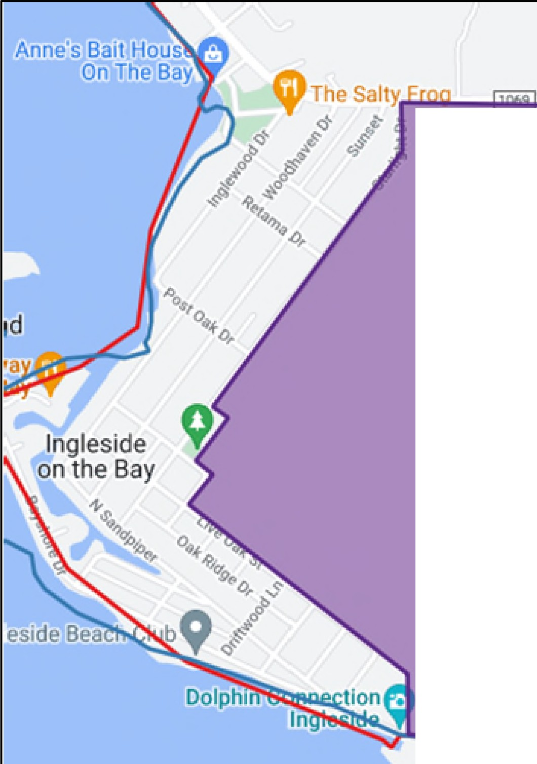
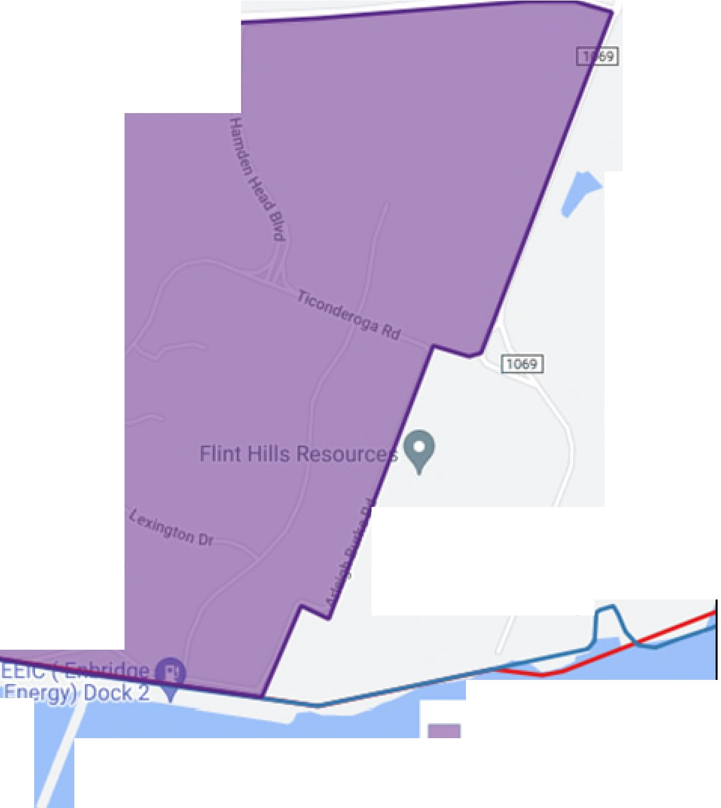
MODA NGLES DEft
E ERGY CENTER T

Hnt Hills lnglesideC.,

Pr qect Re' nvestm.ent Zone
□
Prqect Boundary
C In esid'e ISD
□
San Pa1ffido Co11..1ntv

