Enbridge TCEQ Federal Operating Permit (FOP) O3906 Talking Points (Revision #1)
1/11/24 at 7:00 pm (Portland Community Center, 2000 Billy G Webb Dr, Portland): Public Notice and Comment Hearing

What To Expect at The Hearing
Question | Answer
What is an FOP? | A 5-year Federal Operating Permit (FOP) specifies requirements & conditions under which a polluting industry must operate. It incorporates other air permits, but does not authorize new construction.
Why did we get this Hearing? | At the request of IOBCWA, Sen. LaMantia and Rep. Lozano wrote a letter asking TCEQ for this hearing, so we can learn more about Enbridge’s operations so close to IOB on the former Navy Base property.
How will the hearing be conducted? | TCEQ will manage the hearing. Enbridge will be there. There will be two parts:  - Part 1: Off-the-Record 30-minute informal discussion with applicant and TCEQ.  - Part 2: On-the-Record Statements that TCEQ must respond to in writing and share with EPA
How long can I speak? | Part 1 (first 30 minutes): Open discussion with Enbridge and TCEQ during registration period.  Part 2: 5 minutes max (possibly less, if a lot of folks sign up to speak)  (always do #1 below, most will also do #2; some may be comfortable to add #3 a, b, and/or c)
What should I say during Part 1: Off-Record Q&A? | - Part 1 only lasts 30 minutes (possibly from 6:30-7:00), is off-record, and does not require written response unless the issue is also brought up in Part 2. So don’t waste this time on accusations.  - Limit to only questions you don’t know the answer to or that would yield NEW information that might cast even more doubt on wisdom of TCEQ issuing Standard Operating Permit (SOP)  - Note responses to questions of interest, so you can make on-record statements in Part 2.
What should I say during Part 2: On-Record Statements? | #1) During on-record Part 2, always include these two statements:  - Please extend the comment period so we can consider the information presented tonight.  - I oppose this permit. [TCEQ will tally up the numbers of people for and against.]  #2) Describe your personal experience & knowledge related to Enbridge; show outrage & concern:  - As a resident of IOB, I personally have experienced (describe all that apply – IN DETAIL):  - Exacerbation of existing health conditions (e.g., asthma, COPD)  - Bad odors that smell like petrochemical products; Disruptive noises and alarms  - Close calls with ships  - Anything else, like complaints filed, visual smoke, etc.  - Several of my friends and neighbors (provide addresses) have moved out of IOB because of Enbridge, due to worsening health (be specific), smoke/pollution, noise, property values…  #3a) Make statements about answers given during the Q&A –disagree; express doubt & concern #3b) Describe technical concerns with Site Operating Permit (SOP) and conditions to change/add  #3c) Use some of the talking points on next page - and let IOBCWA know if you want more details
What is in this FOP? | For those who want to dive in to the details, the FOP includes two main documents:  - Site Operating Permit (SOP) identifies all emissions sources, limits, safeguards, and controls for limiting emissions – this is the document TCEQ can change in response to comments  - Statement of Basis (SOB) justifying why these emissions are acceptable  It also incorporates, by reference, New Source Review (NSR) for TCEQ Air Permit 122362 - for which IOBCWA requested a TCEQ Public Meeting & Contested Case Hearing in 2021 (not granted yet).
What is the history of this FOP? | 1/17/18: Original 85-page SOP issued to Oxy for 5 years.  1/21/21: 107-page streamlined revised SOP issued to Moda.  6/8/23: 132-page Draft SOP renewal issued to Enbridge.
Can I submit comments in writing? | Yes, but they must be submitted before the end of the Jan. 11th hearing.  Written comments can be fairly long. You can also upload photos, images, and maps.  Go to https://www14.tceq.texas.gov/epic/eComment/, enter Permit 3906, and complete the form.  Even if you submit comments on line, PLEASE attend the hearing in person and speak up!
What happens after the hearing? | - TCEQ Executive Director will craft a written “Response To Comments” (RTC) made in the hearing.  - TCEQ may identify changes to FOP and Special Conditions, but will likely still renew the permit.  - EPA will review the RTC and oversee issuance of final (hopefully strengthened) permit.
What is the big problem with this FOP? | From 2012 (when Oxy bought it) until 7/15/22, the entire former Naval Station Ingleside property was considered to be a single site under SIC 5171: Petroleum Bulk Stations and Terminals).  After considerable back and forth, Enbridge finally convinced TCEQ to split the site into two sites:  - SIC 4226 for crude oil: primarily engaged in warehousing and storage of special products not elsewhere classified, including petroleum and chemical bulk stations & terminals for hire  - SIC 4925 for LPG: engaged in manufacture and/or distribution of gas for sale, including mixtures of manufactured with natural gas  Enbridge must be treated as a single site, encompassing all the former Navy property that it owns, under SIC 4226. That way, all their emissions will be considered together.
Why is TCEQ’s splitting Enbridge into two sites bad? | A recent article from Inside Climate News (in a series on TCEQ) points out Enbridge is dividing into separate sites to keep under emissions thresholds and avoid Clean Air Act requirements for pollution control technology, air modeling, impact analysis & public involvement. TCEQ does not add emissions from different “sites” together to assess cumulative impacts on nearby communities.
How does this relate to the Ammonia Plant? | If Enbridge gets away with splitting the single property into two sites on this FOP, it will continue splitting the former Navy base property into multiple sites for other products, like ammonia. This obscures the total amount of emissions impacting IOB and surrounding communities. Where will it end? If this FOP is approved as is, Enbridge won’t even have to mention that it has any connection to the ammonia plant! Express concern & outrage that future emissions from Enbridge, such as its current plans for ammonia and hydrogen, will not be considered as part of this FOP.
What do lawyers & experts say? | Let us know if you would like more info to speak intelligently at the Hearing on any of the following:  - Splitting Permits into two sites is sham permitting: Enbridge Terminal is a Single Stationary New Source & a Single Major Source of Pollution  - Enbridge has Hundreds of Environmental Citations, yet has a perfect TCEQ Compliance Rating  - Lax oversight of Enbridge by TCEQ has failed to minimize emissions impacting IOB  - The permit fails to assure compliance with LPG requirements  - Emissions from blasting & coating operations occurred for 5 years without authorization  - The permit fails to include monitoring, testing, recordkeeping, and reporting requirements for marine loading VOC emissions – which can be seen and smelled in IOB  - Some testing methods aren’t shared and some data in Special Conditions are confidential, making it impossible for IOB to know when Enbridge is out of compliance with Clean Air Act  - Enbridge should use Best Available Control Technology, such as video imaging spectro-radiometry to continuously measure their claims of 99.99% combustion efficiency
What are some other talking points? | - IOBCWA has requested, but not been granted, a public hearing and Contested Case Hearing for Permit 122362. Since those emissions should be part of this FOP, when can we expect those?  - Despite numerous requests, TCEQ has not met with IOBCWA to discuss numerous Optical Gas Imaging (OGI) videos of fugitive emissions taken in 2021 & 2022 and the resulting investigations  - When Oxy bought the property from the Port of Corpus Christi, they made some representations to City of Ingleside about having a “significant buffer” between it and IOB. Enbridge has since:  - tried to get a tax abatement to put in a solar farm on the buffer so they can appear to be “net-zero” by selling power back to the grid – Ingleside ISD turned them down  - has convinced the U.S. Army Corps that they can use that buffer as mitigation for a U.S. Army Corps permit to build a new pier even closer to IOB  - started cutting down trees without a permit to build an ammonia production plant inside the original buffer, which is shown on Ingleside City Ordinance 1061.  - Vessel accidents involving Enbridge, Flint Hills, & Buckeye next to IOB show hazardous conditions:  - 2021: a ship collided with the Moda pier, which juts way out into the water  - Christmas Eve 2022: Flint Hills had a 14,000 gallon oil spill  - January 2023: A VLCC from Buckeye collided with a tugboat, which had to be grounded  - August 2023: An Enbridge dredger capsized  - IOB needs to be formally protected with a significant buffer, as promised when Oxy moved in.

Figure 1: From City of Ingleside Ordinance 1061 granting Objectionable Use & showing IOB-Oxy Buffer, passed 7/10/12
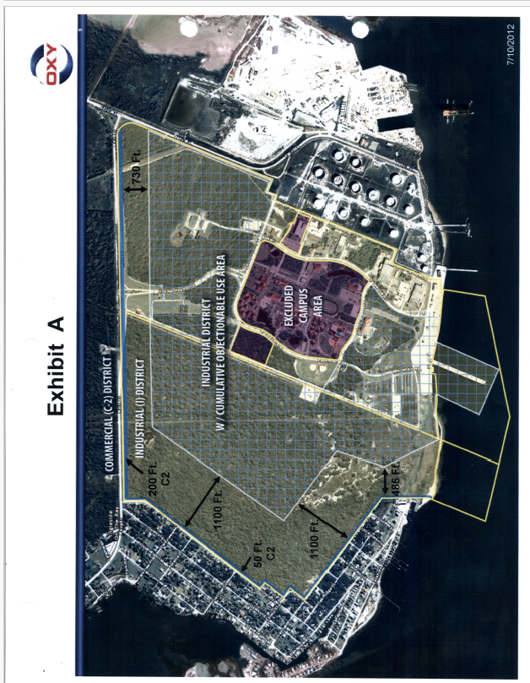
Note: When Oxy bought the property in 2012, they promised there would always be a “significant buffer” between IOB and the operational part of the plant, but it was never codified. Formalizing that buffer between Starlight & Live Oak Drives in IOB, as shown above, as a conservation easement could be ONE of the Special Conditions on THIS FOP.

Figure 2: City of Ingleside Resolution 1075 shows existing Objectionable Use FOR PETROLEUM, passed 11/13/13
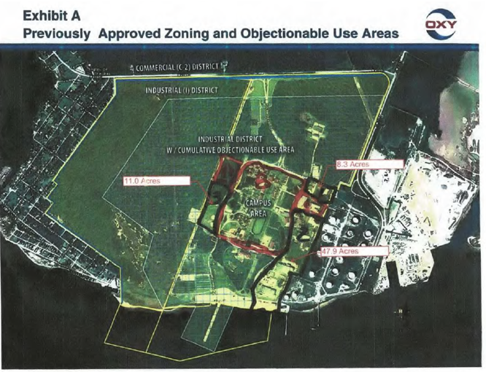
Note: On 1/16/23, City of Ingleside will vote whether to allow objectionable uses for ammonia on the “Campus Area” and the 67.2 acres outlined. This will create a corridor from the ammonia plant to the water. Enbridge says they have abandoned plans to put a solar farm on the vacant land and McGloin’s Bluff historic Karankawan site. They now plan to do something else – maybe worse! IOBCWA, Indigenous Peoples of the Coastal Bend, and Karankawa Kadla have just filed an Appeal in the U.S. Fifth Circuit Court of Appeals to stop Enbridge from adding a second pier closer to IOB.
Figure 3: Enbridge’s Plan for the former Navy Base –3 Different TCEQ Sites So Far! Where will it end?
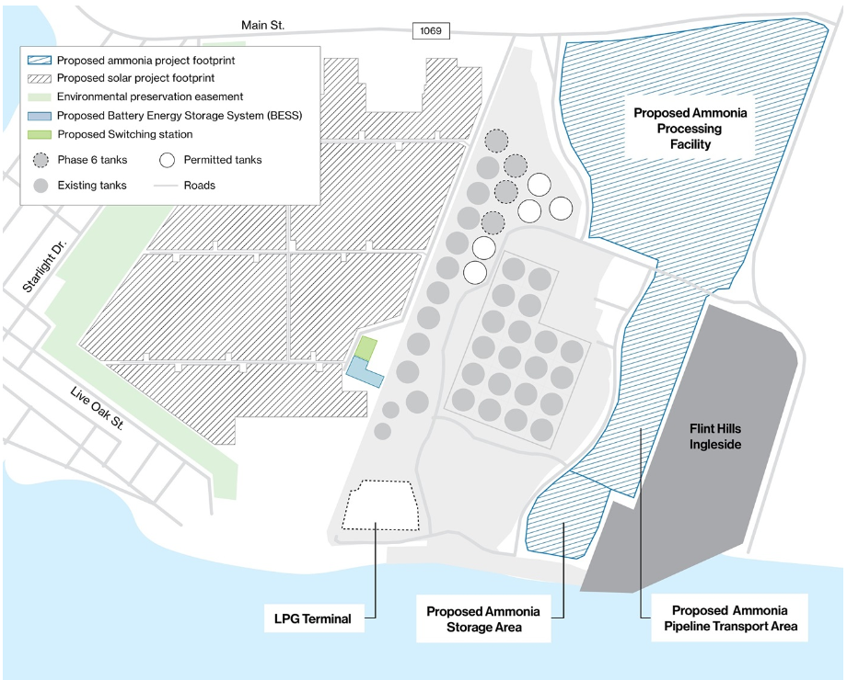
Note: The “Proposed Ammonia Pipeline Transport Area” and “Proposed Ammonia Storage Area” are what Enbridge wants the City of Ingleside to grant as “Objectionable Use” on Jan. 16th at 6:30 pm at Humble Center. All sites share a single marine terminal. This is what we KNOW they want to do. What will they try to do in the undesignated areas closest to IOB? In the federal lawsuit, Enbridge is trying to mitigate the destruction of 10 acres of seagrass and wetlands for the second pier by putting a 70 acre strip along the IOB border into conservation easement, as shown above. Records show that such a conservation easement was granted decades ago, but never carried out.

Historical Development of the former Naval Station Ingleside Property
In the interest of transparency, the City of Ingleside has created a website for all the actions they have taken related to development of the former Navy Base, which was prematurely ordered closed by the 2005 Base Realignment and Closure (BRAC) Commission. The base was only open for 18 years, from 1992-2010. The region still suffers from the loss of this large employer (more than 3000 people).

It does not make sense for TCEQ (let alone the City of Ingleside) to replace a once-vibrant Navy Base employer with an aggressively-expanding foreign-owned company (Enbridge) that:
- routinely harms people and environment
- has a track record of pollution violations
- only hires a few dozen people
- makes foreign-owned companies rich, while avoiding local taxes
- risks safety of the local population with toxic leaks, spills, collisions, explosions, and potential terrorist actions
- threatens to destroy a historical Karankawan site eligible for the National Register of Historic Places
- contributes to global climate change, which worsens sea level rise and flooding for Texas coastal communities

Enbridge knew when it bought the property that it is located next to the City of Ingleside on the Bay, but it has done everything it can to obscure this fact. USACE, TCEQ, and the City of Ingleside have all approved permits that harm IOB, forcing IOBCWA to file lawsuits at every turn. It is time for TCEQ to do its job to protect human health by requiring Best Available Control Technologies (BACT) for all equipment currently in use and to put safeguards in place that limit any further expansion by Enbridge.

