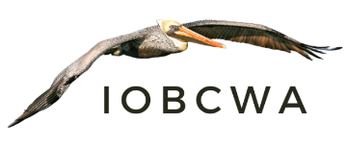
Ingleside on the Bay Coastal Watch Association
1018 Bayshore Dr.
Ingleside, Texas 78362-4840
iobcwa.org

Enbridge/Yara (Ingleside Clean Ammonia Partners, LLC)
Pollutant Health Risks - Google

Enbridge, a Canadian company, and the largest oil export terminal in North America has teamed up with Yara, a Norwegian company to build a Blue Ammonia facility that will use natural gas as the feedstock. The List of Yearly Pollutants are shown below with Google descriptions of the health risks for each. It is shocking how every pollutant will harm the respiratory system and other major health effects.
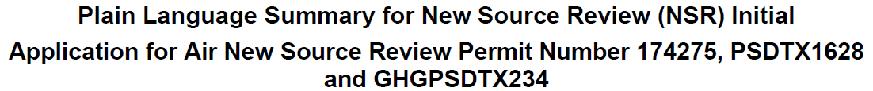

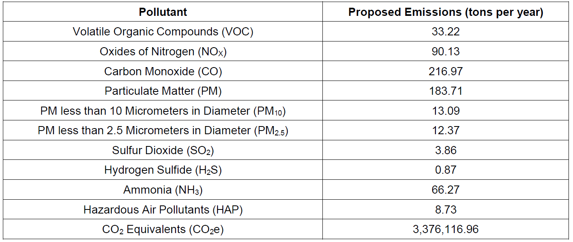

Volatile Organic Compounds (VOC) 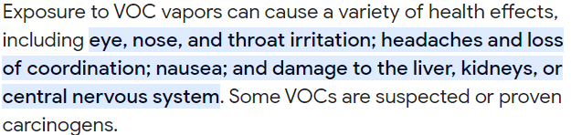
Oxides of Nitrogen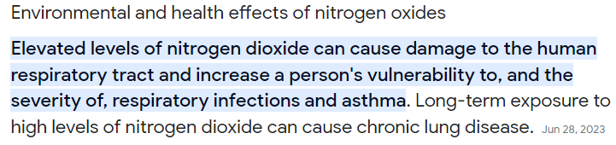
Carbon Monoxide
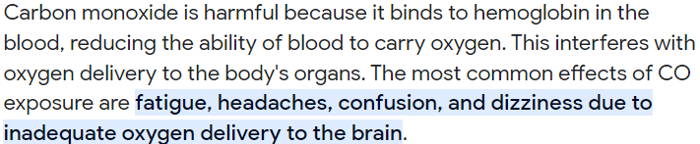

Particulate Matter 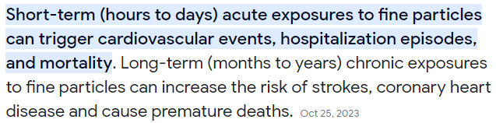
Particulate Matter 10 Micrometers 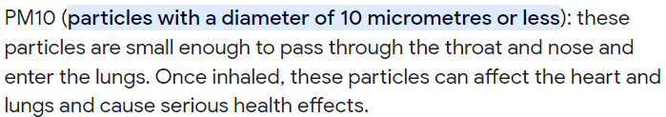
Particulate Matter 2.5 Micrometers 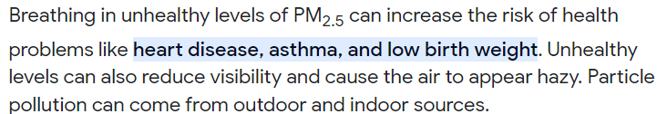

Sulfur Dioxide 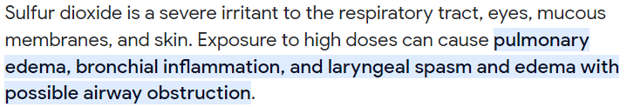
Hydrogen Sulfide 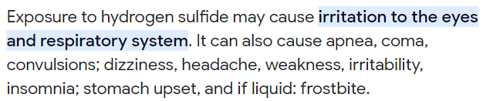
Ammonia 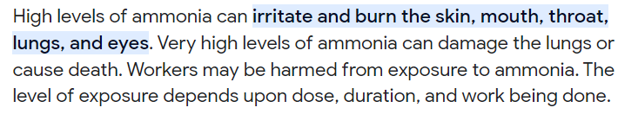
Hazardous Air Pollutants (HAP) 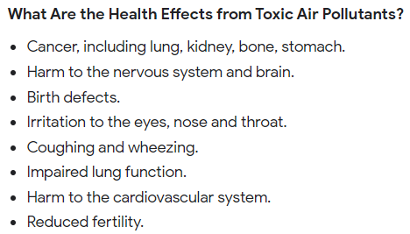
Carbon Dioxide 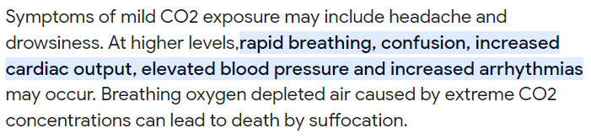

If you have any questions please let me know.

Sincerely,

Patrick A. Nye
President IOBCWA
361-658-1089

